**PROJECT CHARTER/TRANSITION**

|  |  |  |  |
| --- | --- | --- | --- |
| **1. Project Title:** | **Ballard Big Slices and Bold Brews** | | |
|  | | | |
| **2. Client:** | owned by John Cerda, Dylan Cerda and Andy Jolly | | |
|  | | | |
| **3. Project Team:** | | | |
|  | **Name** | **Telephone** | **Email** |
| **Team members:** | Maksim Zubritckii | 309-750-6220 | mzubrit@ilstu.edu |
|  | Oluwatoba Paul Adegbite | 816-316-9720 | opadegb@ilstu.edu |
|  | Tejas Chowdary Mandalapu | 309-533-4132 | tcmanda@ilstu.edu |
|  | Uriel Kwaate Quartey | 309-706-3102 | ukquart@ilstu.edu |
|  | | | |
| **4. Background Information:** | | | |
| An opportunity for a restaurant was recognized in an underutilized location. ​  The town of Chenoa is geographically located in a high traffic area, between Interstate 55, Route 24, and perhaps one of the most nostalgic roads in the country, Route 66. ​  Ballard is a town in between Chenoa and a neighboring town, Lexington. ​  Founder, Andrew Jolly grew up and farmed in the area that was once Ballard. A portion of the crops used to make our beer will be from the old Ballard Township.  Pizza, Big Slices, Skillet Cookie, and guest chefs. ​Our big slices will be something you don’t have to wait 30 min for. We want you eating (and drinking) in the first 5 min you arrive at our location. ​20 tap options serving beer/cider/cocktail/wine/coffee | | | |
|  | | | |
| **5. Business Requirements:** | | | |
| UNDERSTANDING THE CLIENT’S REQUIREMENTS​  - USER STORY​  - THE PURPOSE OF THE WEB APPLICATION​  - THE TARGETED AUDIENCE ​  DRAFTING A BUSINESS REQUIREMENT DOCUMENT (BRD)​  PLANNING ​  - Wireframing ​  - Sitemap​  SELECTING THE TECHNICAL STACK​  - CHOOSING THE FOUNDATION FOR THE WEBSITE​  - CHOOSING THE PROGRAMMING LANGUAGE ​  - ADDITIONAL SERVICES ​  MILESTONE BIFURCATION | | | |
|  | | | |
| **6. Business Problem - Scope of work** | | | |
| Ballard Slices and Brews is in dire need of a newly created website for their restaurant.  This project aims to create a fully functional website for the yet to open restaurant, that is first and foremost, a tool to convey information and foster productive interactions with the customers. We will be addressing the following issues.   * The ability to place an order * A geolocator to get the distance to the restaurant * A Contact Us feature * Social Media Integration * A place for Customer reviews * The ability to book an appointment page with a calendar feature * A link to a Payment portal | | | |
|  | | | |
| **7. Proposed Solution** | | | |
| A restaurant website that is:   * A more user-friendly and usable site architecture and navigation * A clear strategy for how to develop and maintain website content on an on-going basis * A more streamlined infrastructure with decentralized workflow * A homepage that is intuitively designed around user-identified critical tasks * A reservation page which requires; Room location, service type, date and time * A payment portal to accept payments after an order is placed * A geolocator to get the distance which will be fed into the price quote * A customer review section * Social media integration which helps to build traffic * A contact page where guest can reach out to administrators of the restaurant | | | |
|  | | | |
| **8. User/Customer Role** | | | |
| 1. **Book or make Room Reservation:** Can book an appointment for room or Brewery tour based on the schedule and availability of the Ballard management team. 2. **Place orders:** Can place orders using either credit card, debit card or Paypal by clicking on the “Menu” menu. 3. **Post reviews:** Can post reviews about restaurant experience the website which will be reviewed by the administrator before going live 4. **Contact Ballard team:** Can contact Ballard team by providing name, email and message or by calling service team directly by phone. 5. **Viewing site information:** Can view website information, view menu, Geo Locator, social media handles and website gallery. | | | |
| **9. Administrator Role** | | | |
| 1. **Create pages:** Can create/add and publish new pages and information to the website 2. **Edit pages/menu/beer:** Can edit/amend and update existing pages and information on the website 3. **Delete pages/menu/beer:** Can delete and remove existing pages and information from the website 4. **Delete user accounts:** Can delete and remove other user accounts from the website | | | |
|  | | | |
| **10. Software and Hardware Requirements** | | | |
| We will be building the website using a CMS called “Wordpress”. To customize the website, we will be coding in CSS and JavaScript. | | | |
|  | | | |
| **12. Website Design Cost** | | | |
| |  |  |  | | --- | --- | --- | | **No** | **Accuradon Website Project** | **Web Design Costs** | | 1 | Domain Name | $12.00 for first year /$18.00 subsequent years | | 2 | SSL Certificate | $100.00/yr. | | 3 | Website Hosting | $35.00/yr. | | 4 | Content Management System (CMS) | $200.00 | | 5 | Ecommerce Functionality | $1,000.00 | | 6 | SEO and Marketing | $150.00 | | 7 | Database Integration | $100.00 | | 8 | Pages (1 - 50) | $2,000.00 | | 9 | Annual Maintenance Fee | $600.00 | |  | **Total** | **$4,197.00** | | | | |
| **13. Website Design Gannt Chart** | | | |
|  | | | |
|  | | | |
| **14. Use Case Diagram of the Proposed System** | | | |
|  | | | |

**TRANSITION PLAN DOCUMENT**

**ADMIN ROLE:**

|  |  |
| --- | --- |
|  | **Editing the slideshow on the home page** |
|  | **Editing Content on the home page** |
|  | **Editing content on “About Us” page** |
|  | **Adding a new Menu Item** |
|  | **Adding a new location to the map** |
|  | **Adding a new contact in “Contact Us” page** |

**Editing the Slideshow on the home page**

To begin to modify the slideshow information in the default page, in the editor or preview mode, click on the “Ballard Slices and Brews” menu item to open the administrative view.

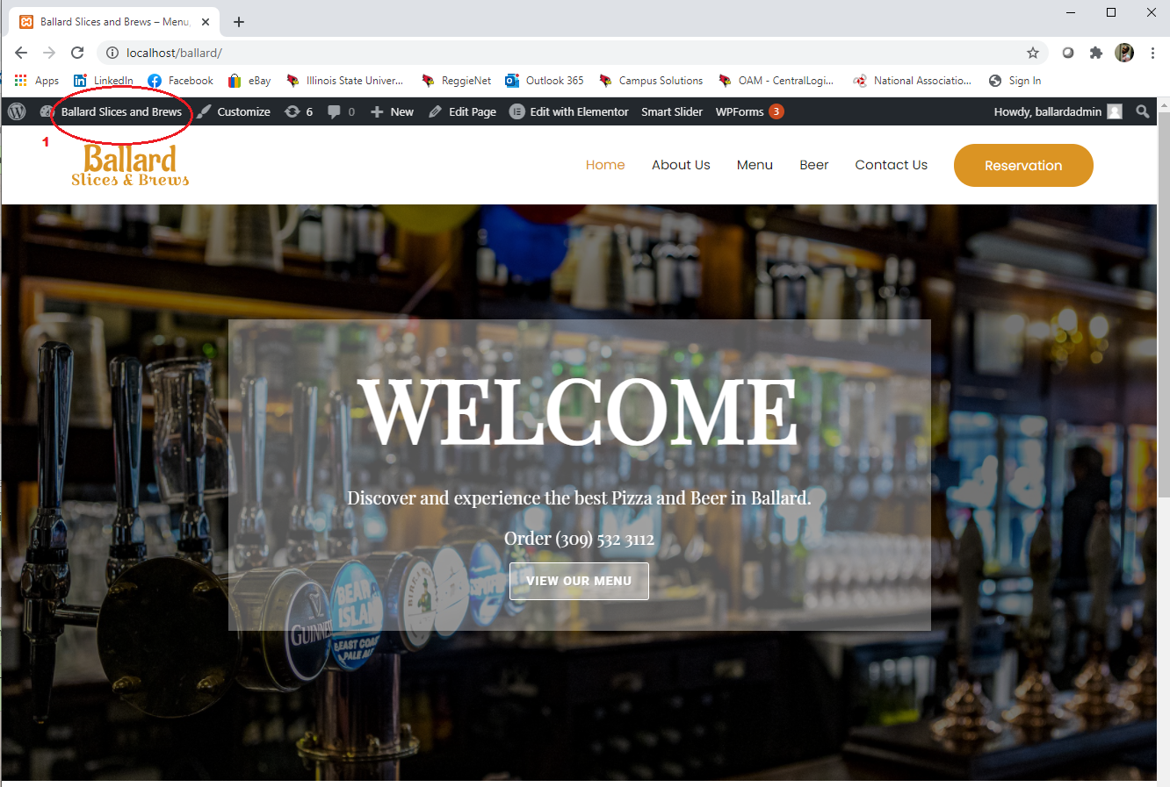

Click on the “Smart Slider” and “Dashboard” menu on the left of the screen

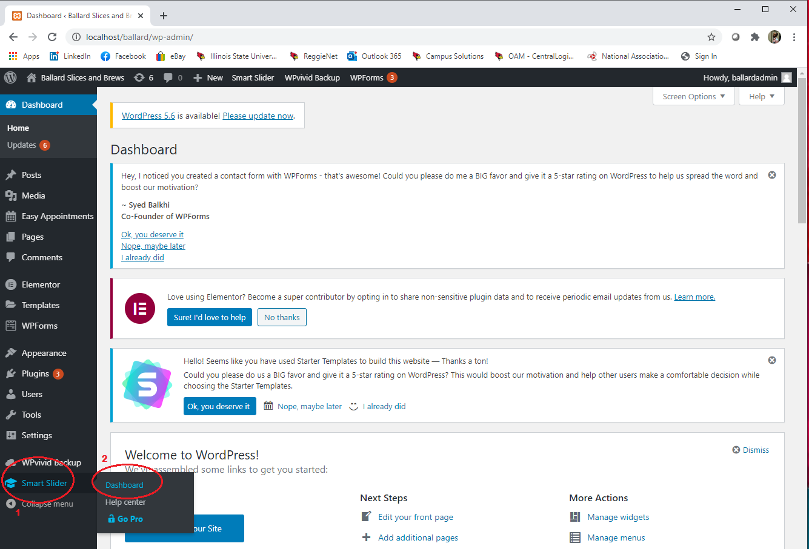

Click on the “Dashboard” in the new window and “Edit” on the screen to make changes to the slider image

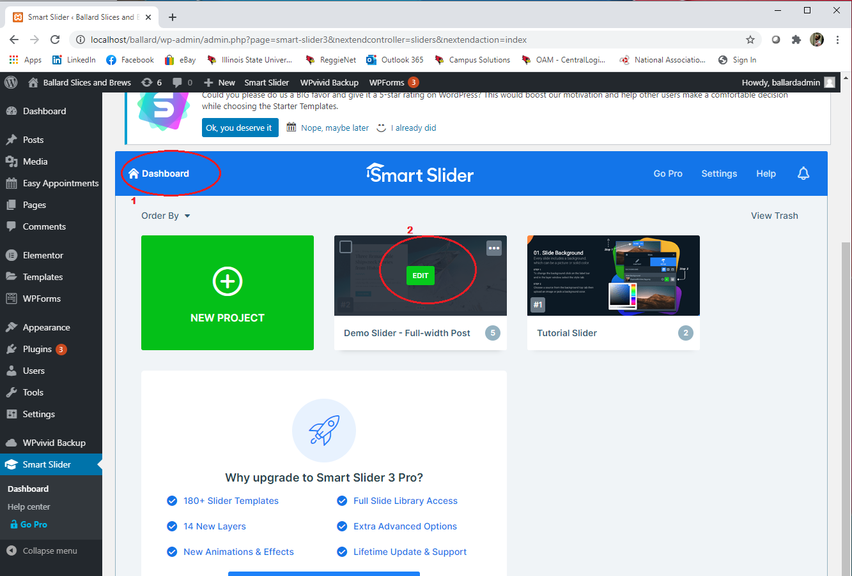

**Editing Content on the home page**

To begin to modify the Home page information in the default page, in the editor or preview mode, click on the “Home” menu item­ and then “Edit with Elementor

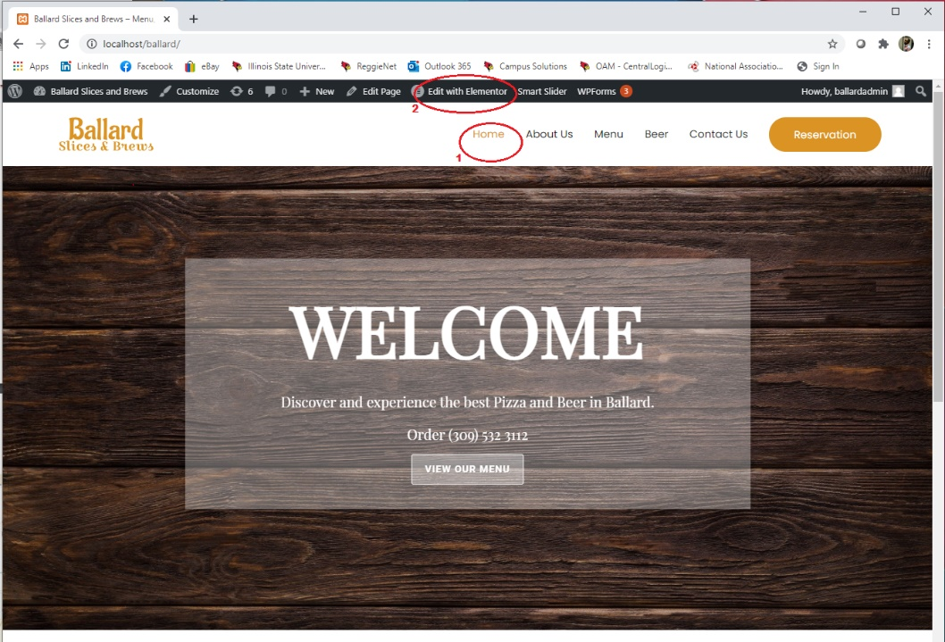

Click on the pencil beside the image item you want to edit. In the image menu on your left, click on the image, title and description to modify and save your new menu item and click on update button at the bottom of the page to confirm your new changes.

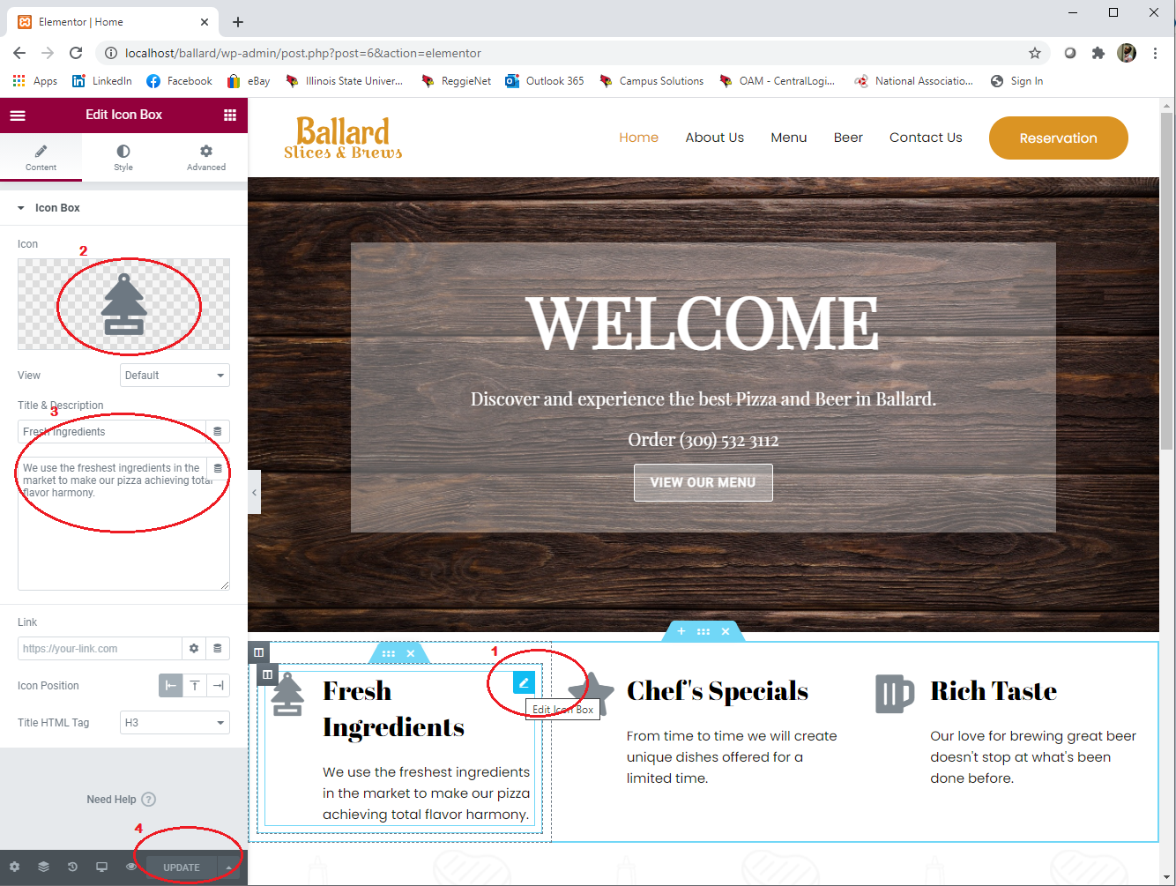

**Editing content on “About Us” page**

To begin to modify a Team information or History information in the “About Us” web page, in the editor or preview mode, click on the “About Us” menu item­ and then “Edit with Elementor

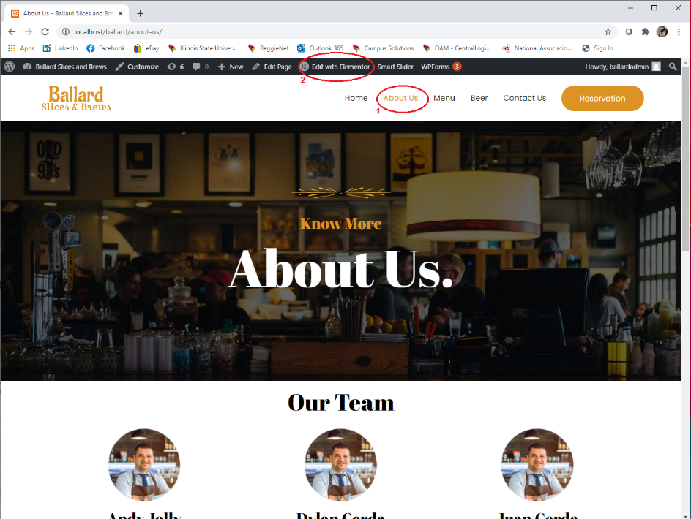

Click on the pencil beside the image item you want to edit. In the image menu on your left, click on the image, title and description to modify and save your new menu item and click on update button at the bottom of the page to confirm your new changes.

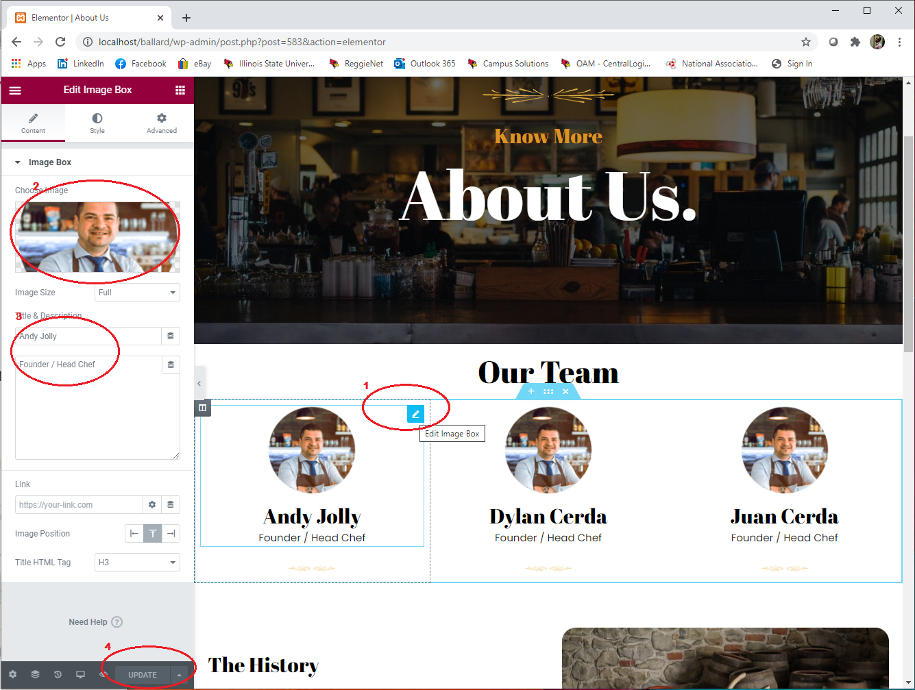

**Adding a new Menu Item**

To begin to add or modify a food item in the “Menu” web page, in the editor or preview mode, click on the “Menu” item­ and then “Edit with Elementor

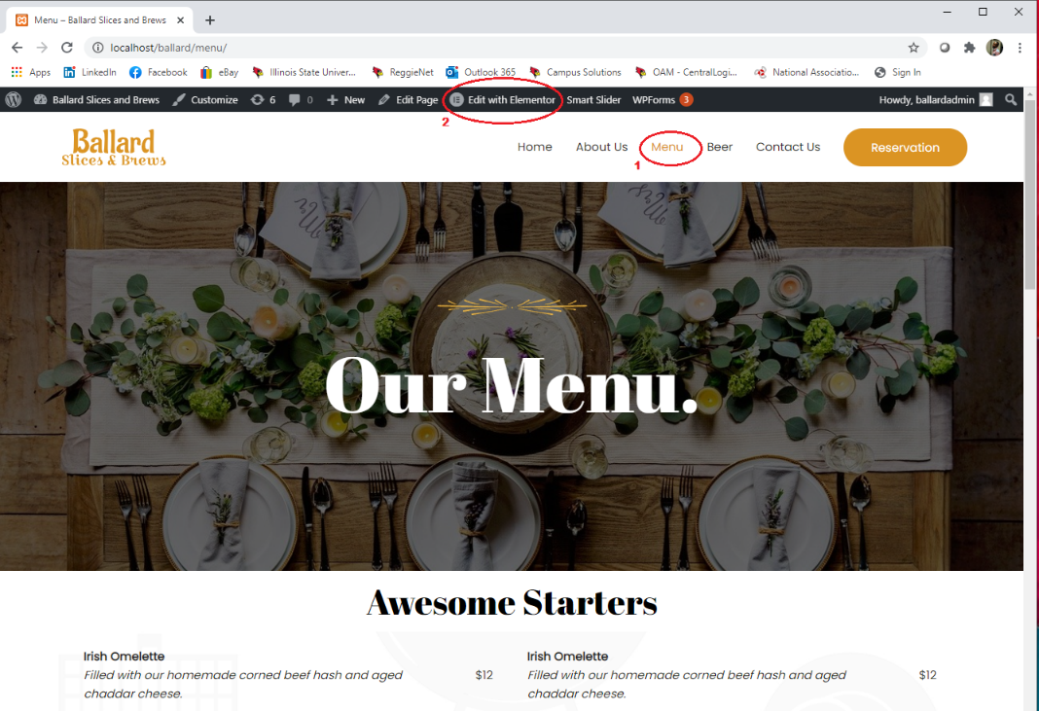

Click on the pencil beside the menu item image to edit the menu item image. In the image menu on your left, click on the image to modify and save your new menu item and click on update button at the bottom of the page to confirm your new changes.

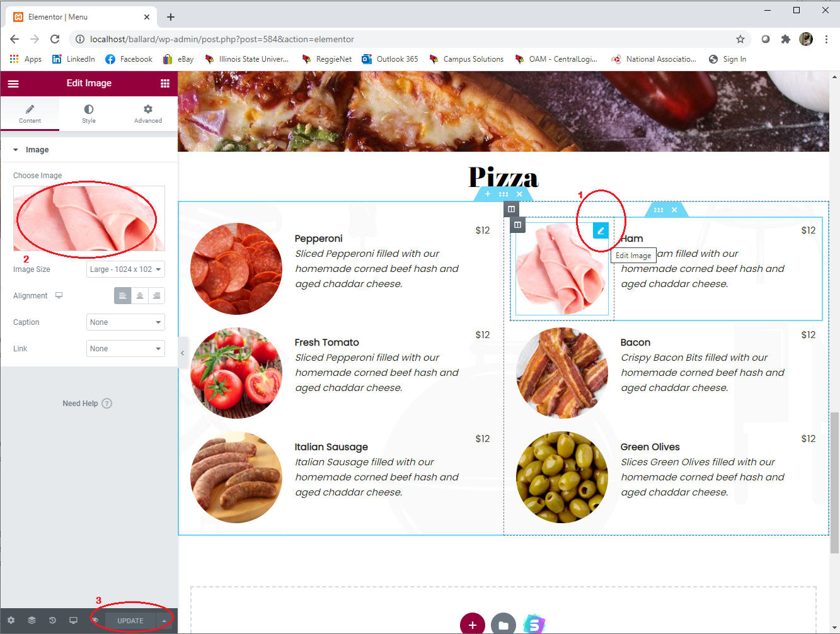

**Adding/ modifying a new/existing contact on “Contact Us” page**

To begin to add or modify a contact in the “Contact” web page, in the editor or preview mode, click on the “Contact Us” menu item­ and then “Edit with Elementor

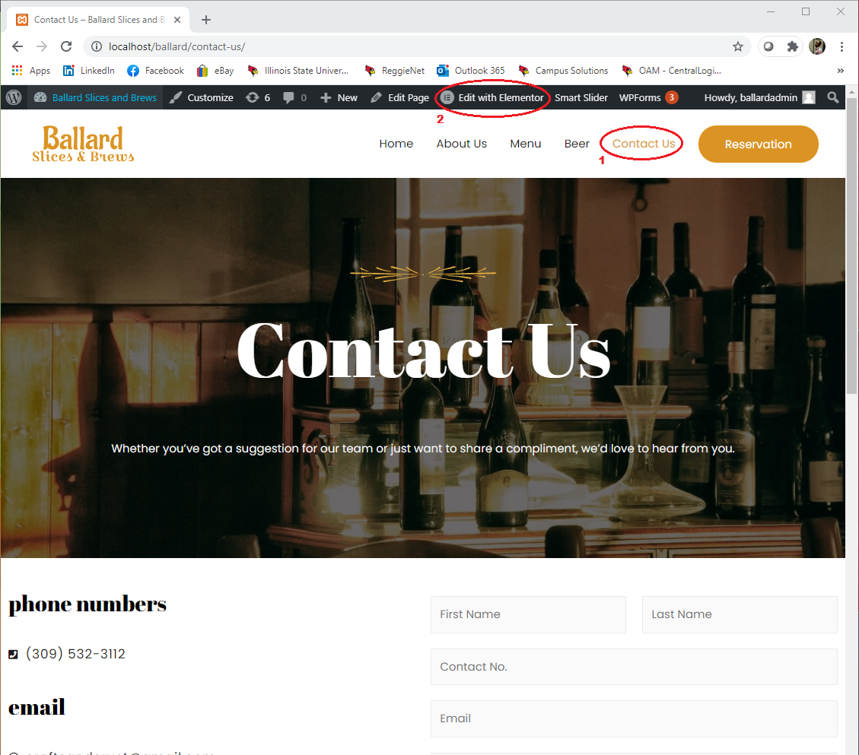

Click on the pencil icon beside the phone number column to edit contact information. In the icon list menu on your left, type your required contact number and click on update button at the bottom of the page to confirm your new changes.

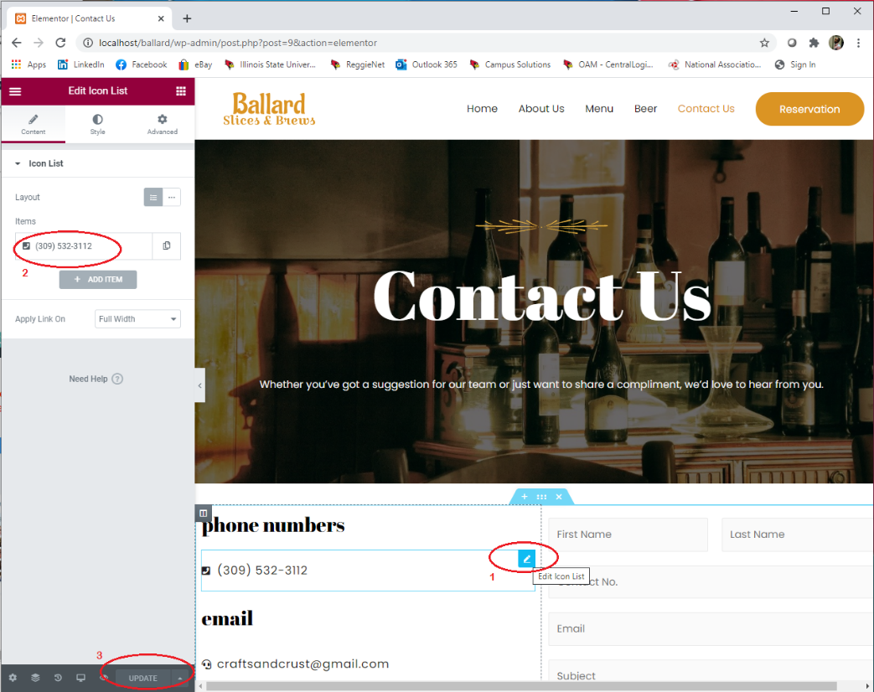

**Adding a new location to the map in “Contact Us”**

To begin to modify a contact in the “Contact” web page, in the editor or preview mode, click on the “Contact Us” menu item­ and then “Edit with Elementor

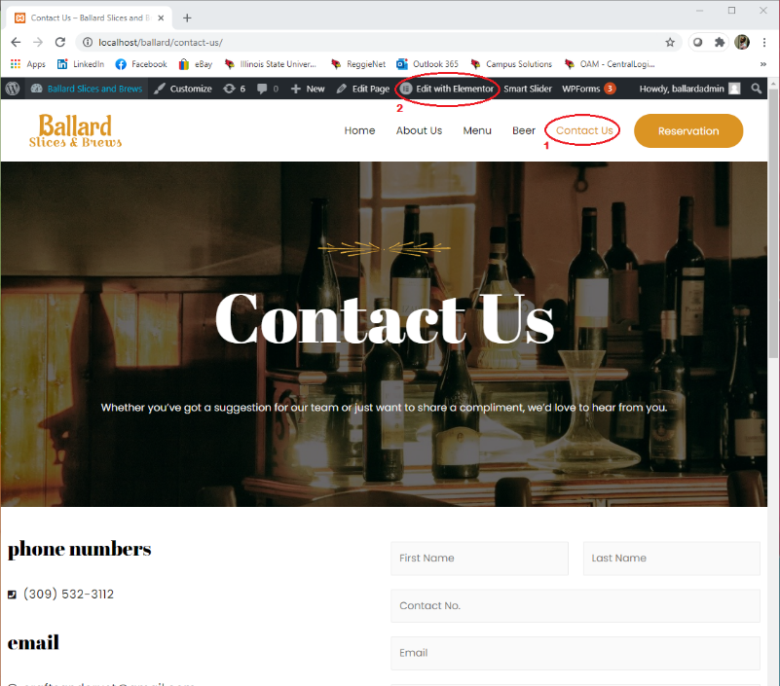

Click on the pencil beside the geolocator (google maps) column to edit map information. In the map menu on your left, enter the address in the location session text box and click on update button at the bottom of the page to confirm your new changes.

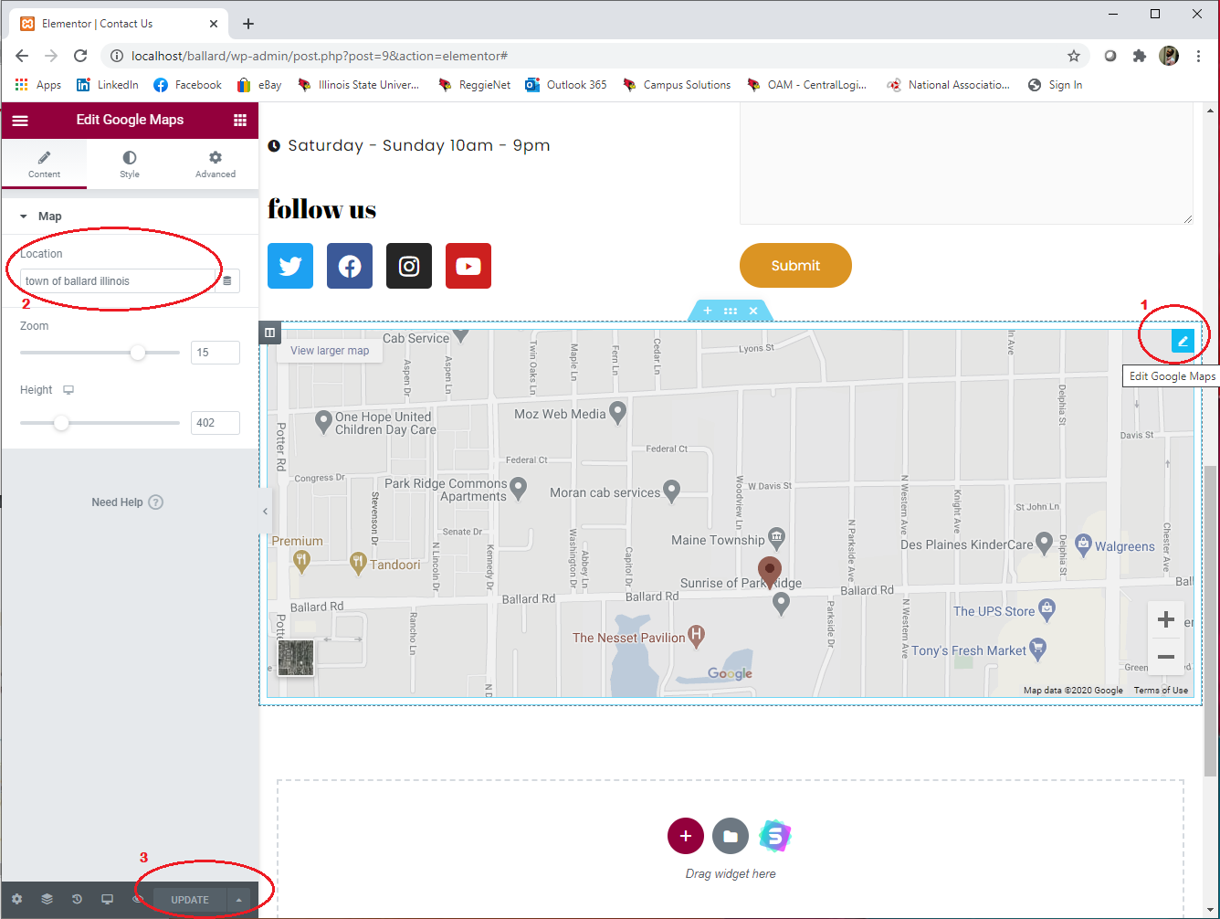

To view your saved changes, one the top left corner, click on bar icon in the elementor tab and then “view page”